User Manual

Visual Novel Engine is used to develop Visual Novels. It’s a form of electronic media such as phones, tabs telling or displaying a story. There are 3 main actors which act during the development and execution of the Visual Novel using the Visual Novel engine.

1. Admin
2. Novel Creator
3. End User – who reads the visual novel

**Admin:**

Admin creates the Visual Novel Engine. In this case we developed the novel engine using Android. Admin provides the source code and explains the procedure to the Novel Creator to create Novels.

**Procedure to create Visual Novel using our Visual Novel Engine:**

There are two major steps which are mentioned below.

1. **Installation of Tools and Project**

* Install Eclipse and Android SDK. Android SDK consists of ADT (Android Developers Toolkit) in it which can be plugged in Eclipse IDE.
* Import our android project into Eclipse.

1. **Using the Project to build the Visual Novel**

* In the imported project, there will be a folder called res which contains all the resources required for Visual Novel.
* Copy all the image files into **res\drawable** folder
* Copy all the audio files into **res\raw** folder
* Novel Creator has to write his own script (mentioned in step **3**) in the format which admin has mentioned and copy the script file also into **res\raw** folder.
* Once everything is copied, then he has to build the project so that it generates the **.apk** file (It is the Visual Novel). This is the deliverable to the end user.

1. **How to write the Script**

* The Script should be in xml format.
* It should consist all the below mentioned tags respective to their resources, so that they get identified while executing the Novel.
* < dialogues> - Main tag. All the script should be inside this tag.
* <dialogue> - Sub tag which contains all the script
  + resource – parameter used inside dialogue for image and audio
  + event – parameter to mention whether image to display and audio to play
  + loop – parameter to loop the audio
  + character – parameter used for image
  + name – parameter used for the name for the image displayed
  + animation – parameter to display in different formats
  + if – parameter to redirect the script
  + mode – parameter to take the input from user (input/choice)
* Text values should be inside the <dialogue> tag.

E.g., <dialogue>Hi Aayush!!</dialogue>

* Please find the example script. This can be used as reference for future scripts.

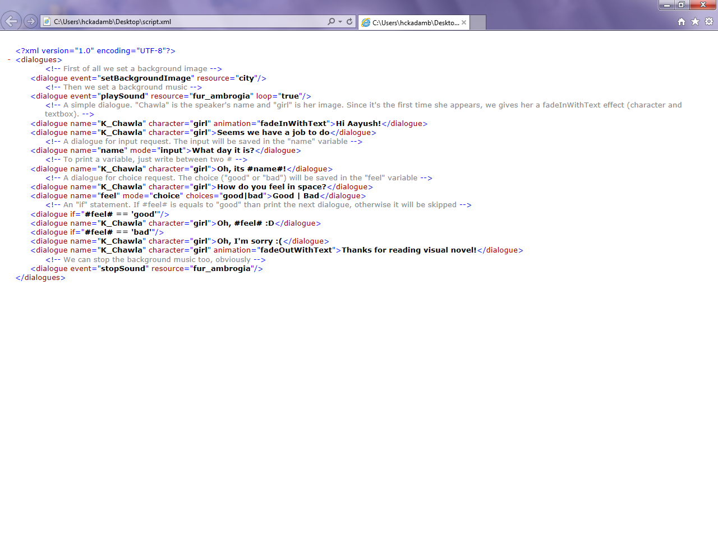

**Novel Creator:**

Novel Creator creates the visual novel using the above mentioned procedure and delivers the apk file which is the Visual Novel to the end user.

**End User:**

End User should install this apk file into his/her phone or tab. Once it is installed successfully, User is ready to read the Visual Novel.